My Care – Proxy Access Frequently Asked Questions

What is meant by ‘proxy access’?

Proxy access enables a third party, for example a parent, other family member or carer etc. to access the patient’s My Care account. The level of access a proxy has can be determined by the patient (or in some cases the health or social care (HSC) professional).

Proxy access enables a significant amount of personal information to be available to the proxy via the My Care patient portal.

A patient can have as many proxies assigned to their account as they choose to, there is no maximum number.

To act as a proxy, an individual must have a My Care account.

Who can access My Care?

Any adult with capacity can access their own record, give access to their record to another person/persons or remove that access

Any person under the age of 18 can request access to their own My Care record once they are assessed by an HSC professional as competent to do so. The level of access granted will be based on the best interests for the young person’s health and which is agreed with them. A young person with capacity has a right to allow or prevent proxy access e.g. by a parent, and proxy access must be granted by an HSC professional.

How can I access My Care?

Individuals regardless of age, will need an nidirect account to access My Care, it is only necessary to verify the identity of the individual and there is no link to your health records. Once your identity has been verified through this method, you will have the option to set up a pin or biometrics (fingerprint) which means you will no longer be prompted to use nidirect when logging in. However, if you would not like to set one of these options up then you will still need to use your nidirect details every time you log in.

Please note, currently, it can be difficult for younger people of post-primary age to apply for an nidirect account without a passport or driving licence. nidirect are currently engaged on developing a long-term solution to this situation, you can contact nidirect support on 0300 200 7814 to find out more information

Can an adult that lacks capacity to make decisions for themselves access My Care?

An adult without capacity or the competency to access their personal care records and requires another adult to act as proxy on their behalf to help with their care needs may appoint said person using the process outlined below.

This would normally be next of kin or another relative or carer. This request will be assessed by a health or social care professional who will decide what level of proxy access is appropriate. Proxy access can be amended or revoked if that individual is deemed to have regained capacity. Personal information on any individual will not be shared more widely that is strictly necessary (e.g. some information can be hidden from proxy view on My Care) and proxy access will be reviewed on an ongoing basis. This will involve a service user or patient doing so by directly contacting a member of the persons care team.

How do I give someone proxy access? What is the process?

To enable someone (usually a family member or carer) to help manage your care with items such as awareness of appointments, or reading and interpreting letters.

How do I give someone proxy access? What is the process?

Any individual with a My Care account can grant another person proxy access. To access My Care, download the app from the app stores or log in using a computer (See ‘How do I Sign Up’). You will need an nidirect account to verify your identify to access your My Care account.

If an individual cannot access their own account independently they can still request access or grant someone proxy access via a health or social care professional.

What can people see when they are granted proxy access?

People will be able to see information including your appointments, results, letters and medications. The level of access can be determined by the person granting access or by HSC professionals. The different levels of proxy access are described in My Care and you can select which one you would like to choose as per the image below:

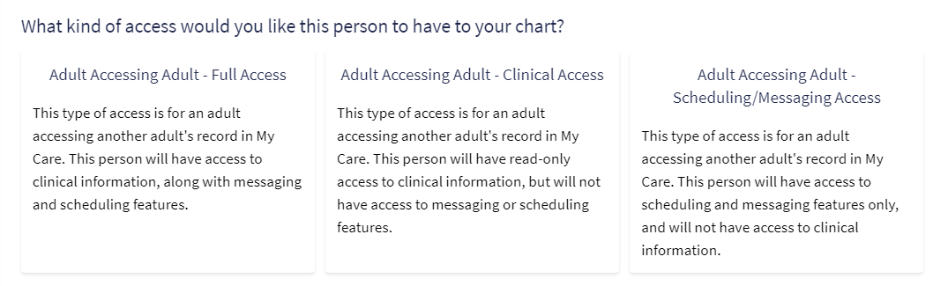

Does proxy access automatically expire?

Any proxy access will automatically expire at the age of 18 unless the individual is assessed not to have capacity or a best interest’s decision is made by health or social care professionals that proxy access should continue.

Any proxy access granted will terminate when an individual dies. It is also important to note that proxy access can be revoked at any given time by an HSC staff member, when safeguarding concerns may arise regarding proxy.

For more information please contact the My Care helpdesk on 028 9536 8180 or emailing on mycarehelpdesk@hscni.net.

